Webserver exploration: NGINX vs Apache

The main difference between Apache and NGINX lies in their design architecture. Apache uses a process-driven approach and creates a new thread for each request. Whereas NGINX uses an event-driven architecture to handle multiple requests within one thread.

Experiment: Single page hosted on Lamp and Lemp servers with apache and NGINX respectively gave following results on 4GB memory 2 core CPU and 80 GBSSD:

Back end time Test: Average time taken by server to generate the response.
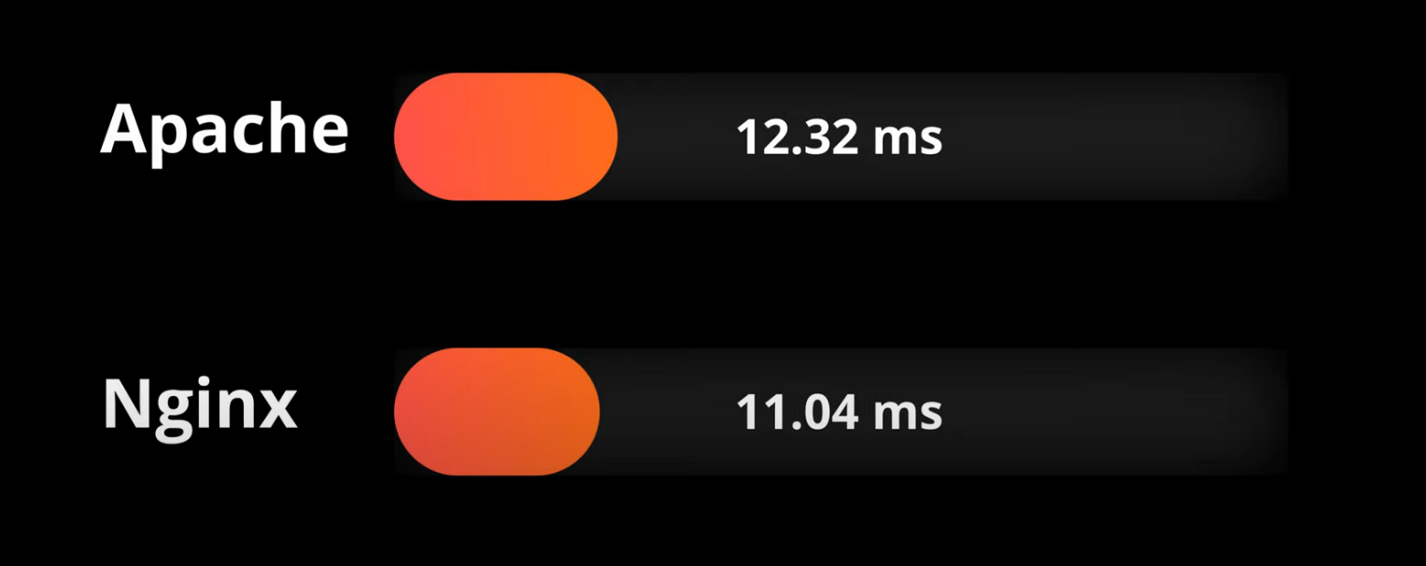

Time to first page: Time taken for loading of first page in new tab 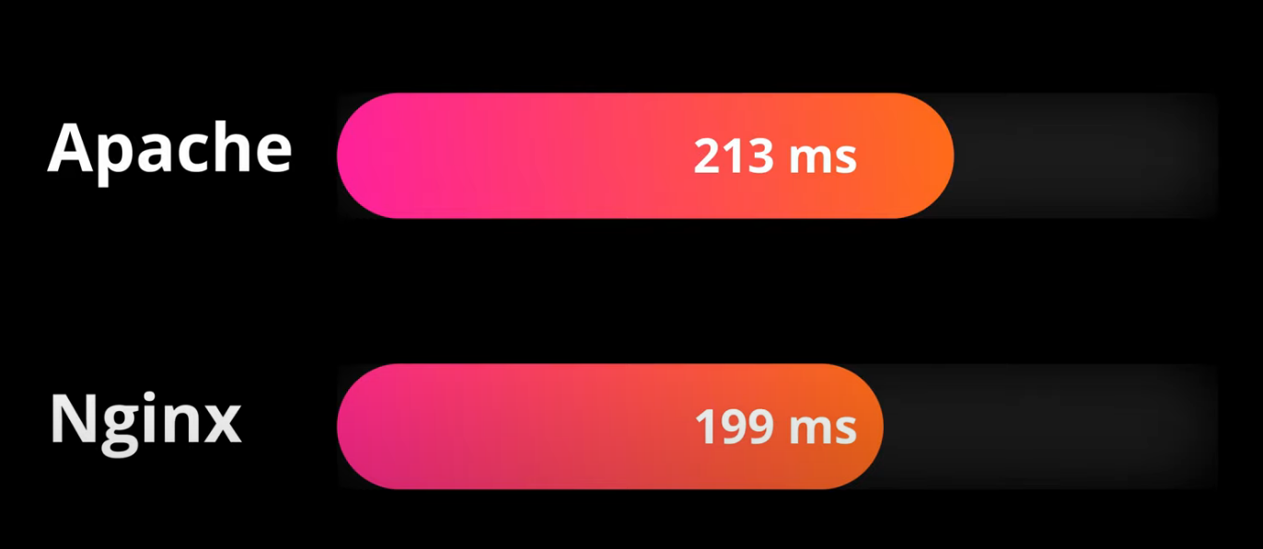

Average page load time
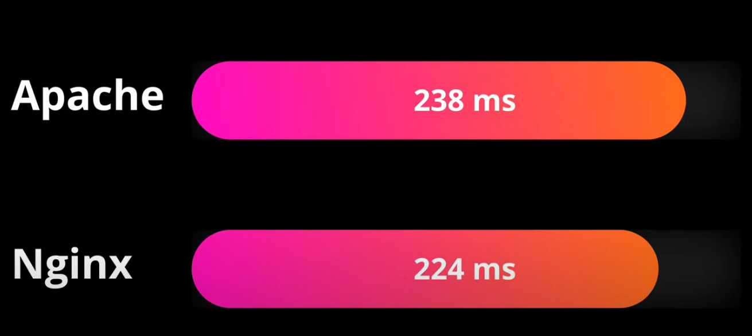

Google trend
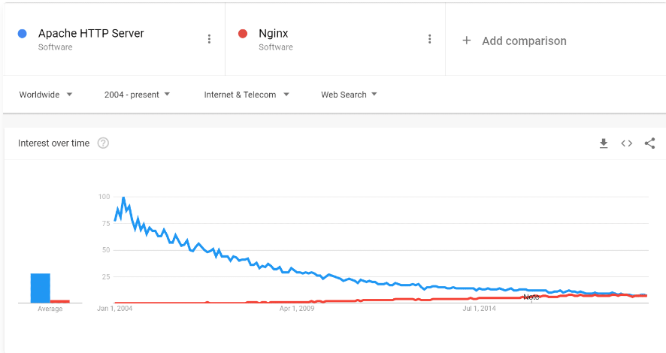
Basic Architecture (Winner: NGNIX It has a lightweight structure, and much faster architecture than that of Apache)

Apache creates new thread for every request, which lead to heavy resource consumption, thereby, can cause issues with the server (e.g. - slow speed).
On the other hand, NGINX Handles multiple requests within one thread. allow Nginx to work very fast and wide with limited resources.

Caching difference: (Winner: NGINX)
NGINX takes clear edge over apache here. While NGINX is very efficient in this, apache can be glitchy sometimes.

Handling Requests: (Winner: NGINX)

In short, Apache uses processes for every connection (and with worker mpm it uses threads). As traffic rises, it quickly becomes too expensive.
We can picture new process or thread creation like booting up of a computer or starting up programs. Even on the fastest of computers, it still takes some time. With websites today making hundreds of requests on a single page load, this quickly adds up.
Event mpm goes a bit further in terms of optimization, but some tests show that it can’t outrun Nginx. Especially when we talk about static files, where Nginx serves as much as double the requests that Apache does.
Nginx ideally has one worker process per CPU/core. The difference of Nginx worker processes is that each one can handle hundreds of thousands of incoming network connections per worker. There is no need to create new threads or processes for each connection.

Static vs Dynamic Content

Static Content - (Winner: NGINX)
Apache Serves static content using the file-based method. Nginx’s design architecture is better equipped to handle the load, it is much faster when it comes to serving the static content. It performs 2.5 times faster than Apache according to a benchmark test running up to 1,000 simultaneous connections.

Dynamic: (Draw)
Apache can process dynamic content within the web server itself without having to rely on any external components. So, it can handle your creeds itself.
Talking about Apache vs Nginx Performance: Nginx, if not better, is almost equal when dynamic content processing is considered.

OS Support - (Winner: Apache) supports more operating systems
OS support can be an important point to consider, especially when comparing Apache vs Nginx. But both are almost similar here.
Apache runs on all kinds of Unix-like systems (e.g., Linux or BSD) and has full support for Microsoft Windows.
It also runs on several modern Unix-like systems and has some support for Windows, but its Windows performance is not as strong as that of other platforms.

Modules - (Winner: Apache) – It is less yet important features and modules make it lighter, smarter, and better web server than Apache. Both Nginx and Apache are extensible through module systems, but the way that they work differ significantly.
Apache
Apache’s module system allows you to dynamically load or unload modules to satisfy your needs during running the server. The Apache core is always present, while modules can be turned on or off, adding or removing additional functionality and hooking into the main server.
Apache uses this functionality for a large variety of tasks. Due to the maturity of the platform, there is an extensive library of modules available. These can be used to alter some of the core functionality of the server, such as mod_php, which embeds a PHP interpreter into each running worker.
Modules are not limited to processing dynamic content, however. Among other functions, they can be used for rewriting URLs, authenticating clients, hardening the server, logging, caching, compression, proxying, rate limiting, and encrypting. Dynamic modules can extend the core functionality considerably without much additional work.

Nginx
Nginx also implements a module system, but it is quite different from the Apache system. In Nginx, modules are not dynamically loadable, so they must be selected and compiled into the core software.
For many users, this will make Nginx much less flexible. This is especially true for users who are not comfortable maintaining their own compiled software outside of their distribution’s conventional packaging system. While distributions’ packages tend to include the most used modules, if you require a non-standard module, you will have to build the server from source yourself.
Nginx modules are still very useful though, and they allow you to dictate what you want out of your server by only including the functionality you intend to use. Some users also may consider this more secure, as arbitrary components cannot be hooked into the server. However, if your server is ever put in a position where this is possible, it is likely compromised already.
Nginx modules allow many of the same capabilities as Apache modules. For instance, Nginx modules can provide proxying support, compression, rate limiting, logging, rewriting, geolocation, authentication, encryption, streaming, and mail functionality
Security (Winner: NGINX)
Apache makes sure that all the website that runs on its server are safe from any harm and hackers. Thereby it offers configuration tips for DDoS attack handling, as well as the mod_evasive module for responding to HTTP DoS, DDoS, or brute force attacks.
The NGINX code base, however, is significantly smaller by several orders of magnitude, so that is a big plus from a forward-thinking security perspective

Distributed / Centralized Configuration (Winner: Apache if configuration is considered; NGiNX if speed is)
Apache architecture allows non-privileged users to control certain aspects of their website without granting them permission to edit the main config. This is big!
It, on the other hand, has a downside. It does not provide additional configuration. However, it works in your favour as this increases the performance.
By not allowing directory configuration It can serve request faster than Apache. It does not need to search for .htaccess files and interpret the req made by the user.

Summary
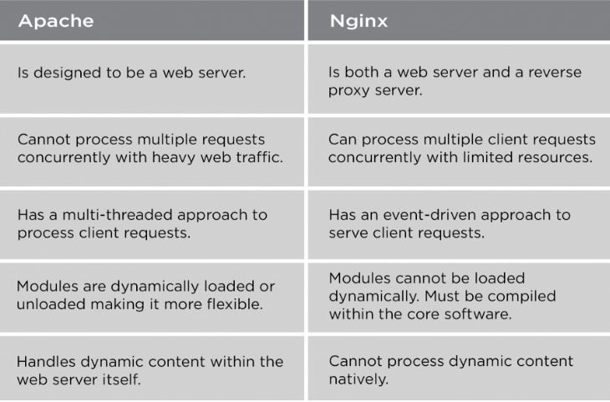

When to choose Apache over NGINX:
- Apache .htaccess: NGINX does not support something like the Apache’s .htaccess file. However, with Apache, you get an advantage to give the non-privileged users control over some important aspects of their website.
- In case of some limitations or needing to use extra modules that are not supported by Nginx, you might want to choose Apache instead.

When to choose NGINX over Apache:
- Fast Static Content Processing
- Great for High Traffic Websites

Using Apache and Nginx Together
After going over the benefits and limitations of both Apache and Nginx, you may have a better idea of which server is more suited to your needs. However, many users find that it is possible to leverage each server’s strengths by using them together.
The conventional configuration for this partnership is to place Nginx in front of Apache as a reverse proxy. This will allow Nginx to to handle all requests from clients. This takes advantage of Nginx’s fast processing speed and ability to handle large numbers of connections concurrently.
For static content, which Nginx excels at, the files will be served quickly and directly to the client. For dynamic content, for instance PHP files, Nginx will proxy the request to Apache, which can then process the results and return the rendered page. Nginx can then pass the content back to the client.
This setup works well for many people because it allows Nginx to function as a sorting machine. It will handle all requests it can and pass on the ones that it has no native ability to serve. By cutting down on the requests the Apache server is asked to handle, we can alleviate some of the blocking that occurs when an Apache process or thread is occupied.
This configuration also allows you to scale out by adding additional backend servers, as necessary. Nginx can be configured to pass to a pool of servers easily, increasing this configuration’s resilience to failure and performance.
